Supplementary File 3: No dataset location found manuscripts

Table 1: Manuscripts labeled as maybe due to failure to ascertain the data collection location
Author ID | title
Ibrahim, W. H et al.,(2013) | MRI brain image classification using neural networks
Abdullah, M. A et al.,(2018) | EEG Emotion Detection Using Multi-Model Classification
Rodrigo, H et al. (2022) | Predicting the Outcomes of Internet-Based Cognitive Behavioral Therapy for Tinnitus: Applications of Artificial Neural Network and Support Vector Machine.
Thilagaraj, M et al., (2022) | Classification of Electroencephalogram Signal for Developing Brain-Computer Interface Using Bioinspired Machine Learning Approach.
Treder, M. S et al. (2021) | Correlation constraints for regression models: Controlling bias in brain age prediction

Evaluation Metrics in Primary studies
Evaluation Metrics
Multiple metrics from the primary studies have helped evaluate the performance of machine learning and statistical models. To further address RQ2, an investigation and identification of evaluation metrics is conducted. The co-authors found that thirty-four evaluation metrics were used in studies incorporating machine learning and statistical techniques in computational Neuroscience studies in Sub-Saharan Africa. The metrics include AUC, SD, Mean±SD, t, b, p, p-FDR, M, ROC-AUC, CI, Accuracy, ROI-to-ROI, Sensitivity, Specificity, Cohen’s d, 95% CI, ROC-AUC±SD, PR±SD, Precision, Recall, Mean age±SD, Mean probability, qs, MAE, ROC Score, F1 Score, RMSE, q, Variance, Mean difference, r, R2, RE – meta, ComBat mega, and ME – mega as shown in Figure 1. AUC and SD were the most employed performance metrics ,followed by Mean±SD, t, b, p, p-FDR, M, ROC-AUC, and CI. Accuracy, ROI-to-ROI, Sensitivity, Specificity, Cohen’s d, 95% CI, ROC-AUC±SD, PR±SD, Precision, Recall, Mean age±SD, Mean probability, qs, MAE, ROC Score, F1 Score, RMSE, q, Variance, Mean difference, r, R2, RE – meta, ComBat mega, and ME – mega were less explored.

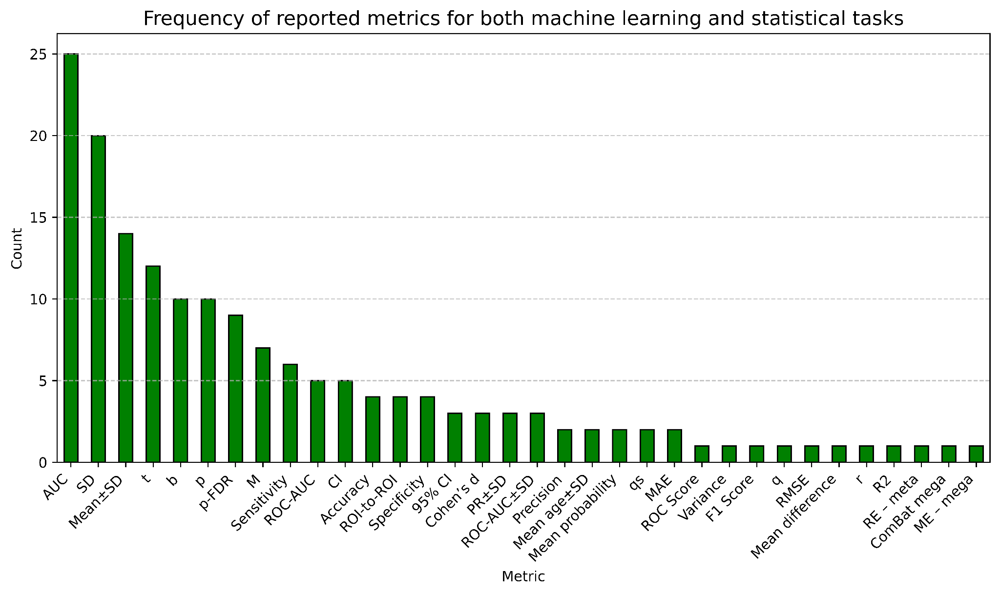
Figure 1: The number of times a specific metric appears in the primary studies.

Table 5: For each metric, we show the best performance and best model under each primary study; these demonstrated strong performance across multiple evaluation metrics and studies.
Study ID | Metric | Best performance | Best model | Best model category
Nyaradzo et al., 2023 | Accuracy | 98.4 | Deep neural network | Classification
Nyaradzo et al., 2023 | Precision | 98.82 | Deep neural network | Classification
Adem et al., 2022 | Recall (Sensitivity) | 96.7 | Multi-class SVM (RBF) | Classification
Nyaradzo et al., 2023 | F1 Score | 97.67 | Deep neural network | Classification
Adem et al., 2022 | Specificity | 98.3 | Multi-class SVM (RBF) | Classification
Nyaradzo et al., 2023 | ROC Score | 99.87 | Deep neural network | Classification
Jones et al., 2023. | AUC | 0.93 | Logistic regression, Naive Bayes, and Support Vector Machine | Classification
Ioannidis et al., 2016. | ROC-AUC±SD | 0.83±0.03 | Logistic regression and Naive Bayes | Classification
Kim et al., 2024. | ROC-AUC | 76.72 | Principal component analysis (PCA) | Classification
Jones et al., 2023. | Confidence Interval (CI) | 0.92-0.94 | Logistic regression | Classification
Nunes et al., 2018 | 95% CI | 69.39–73.59 | Mixed-effects logistic regression – glmer function | Classification
Kerestes et al., 2023 | t | -8.9 (significant) | Linear mixed effects regression models | Statistical
Marshall et al., 2022, Kerestes et al., 2023, Ottino-González et al., 2022, and Radua et al., 2020 | p | < 0.001 (highly substantial) | Linear regression model, Linear mixed effects regression models, Regularized logistic regression, Linear mixed effects model, ComBat harmonization, and Standard linear models | Statistical
 |  |  |  | Regression
Bruin et al., 2023 | Cohen’s d | 0.19 to 0.22 | Linear mixed effects model. | Statistical
Marshall et al., 2022. | qs | < 0.05 | Linear regression model | Statistical
 |  |  |  | Regression
Bruin et al., 2023 | ROI-to-ROI | 0.702 | Support vector machine. | Classification
Han et al., 2022 | R² Score | 0.47 | Ridge regression, Linear mixed models, ENIGMA brain age prediction model | Statistical
 |  |  |  | Regression
Han et al., 2022 | Correlation (r) | 0.73 | Ridge regression, Linear mixed models, ENIGMA brain age prediction model | Statistical
 |  |  |  | Regression
Washington et al., 2020. | Mean probability | 67.75% | Logistic regression | Regression
Huggins et al., 2023 | b | −693.478 | linear mixed effects model,  convolutional neural networks,  Random effects model, and  U-Net | Segmentation
 |  |  |  | Regression
Huggins et al., 2023 | p-FDR | < 0.001 (highly significant) | linear mixed effects model,  convolutional neural networks,  Random effects model, and  U-Net | Segmentation
 |  |  |  | Regression
Radua et al., 2020 | RE – meta | 53.7% | Linear mixed effects model,  ComBat harmonization, and  Standard linear models. | Statistical
Radua et al., 2020 | ComBat mega | 83.5% | Linear mixed effects model,  ComBat harmonization, and  Standard linear models. | Statistical
Radua et al., 2020 | ME – mega | 80.4% | Linear mixed effects model,  ComBat harmonization, and  Standard linear models. | Statistical
Han et al., 2022 | Mean Absolute Error (MAE) | 7.075 | Ridge regression,  Linear mixed models, and  ENIGMA brain age prediction model. | Statistical
 |  |  |  | Regression
Cherukuri et al., 2017. | Mean±SD (Best) | 0.932 ± 0.004 | Feature learning for image segmentation (FLIS),  Discriminative dictionary learning and  sparse coding (DDLS),  Patch-based Sparse representation-based classification (Patch-based SRC), and  Brain Intensity Segmentation (BIS) | Segmentation
Washington et al., 2020. | SD | 9.75% | Logistic regression. | Regression
Koopowitz et al., 2023. | M (Best higher) | 89.4 | General linear regression model | Statistical
Koopowitz et al., 2023. | M (Best lower) | 6.78 | General linear regression model | Statistical
Ioannidis et al., 2016 | PR±SD | 0.01±0.00 | Naive Bayes | Classification
Kerestes et al., 2023 | Mean age±SD | 63.2±9.7 | Linear mixed effects regression models | Statistical

